1.

public class sum {  
 public static void main(String[] args){  
 int[] arr=new int []{1,2,3,4,5};  
 int sum=0;  
 for(int i=0; i<arr.length;i++) {  
 sum = sum + arr[i];  
 }  
 System.*out*.println("sum of all elements: "+sum);  
 }  
 }

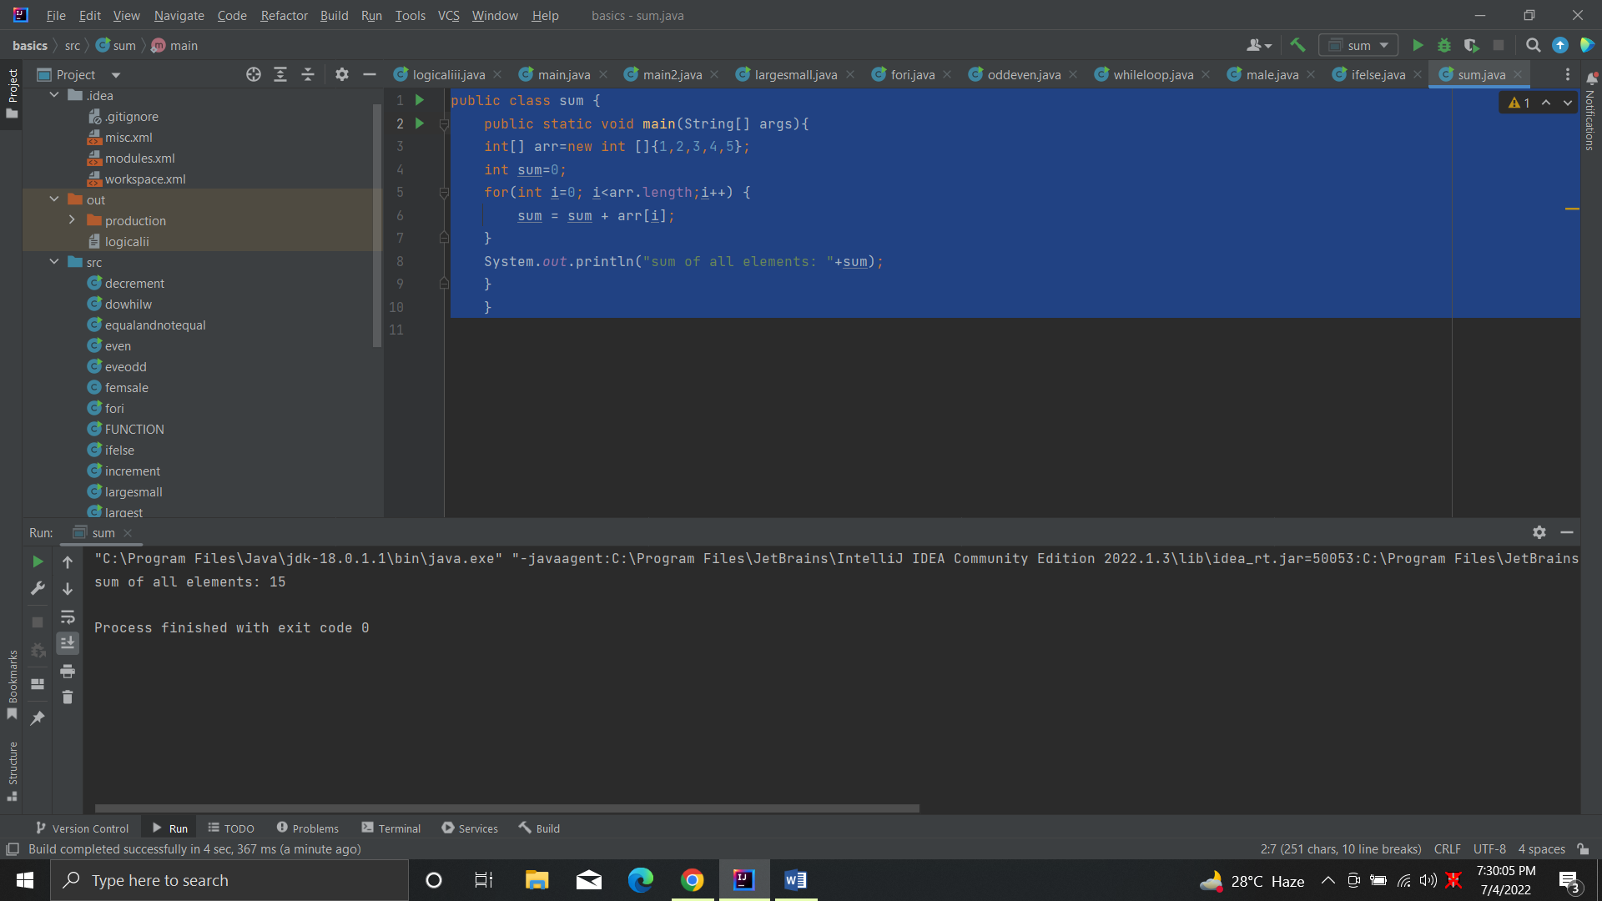

2.

public class average {  
 public static void main(String[] args) {  
 double[] arr = {19, 12.89, 16.5, 200, 78};  
 double total = 0;  
 double average = total / arr.length;  
 for(int i=0; i<arr.length; i++){  
 total = total + arr[i];  
 }  
 System.*out*.format("The average is: %.3f", average);  
 }  
}

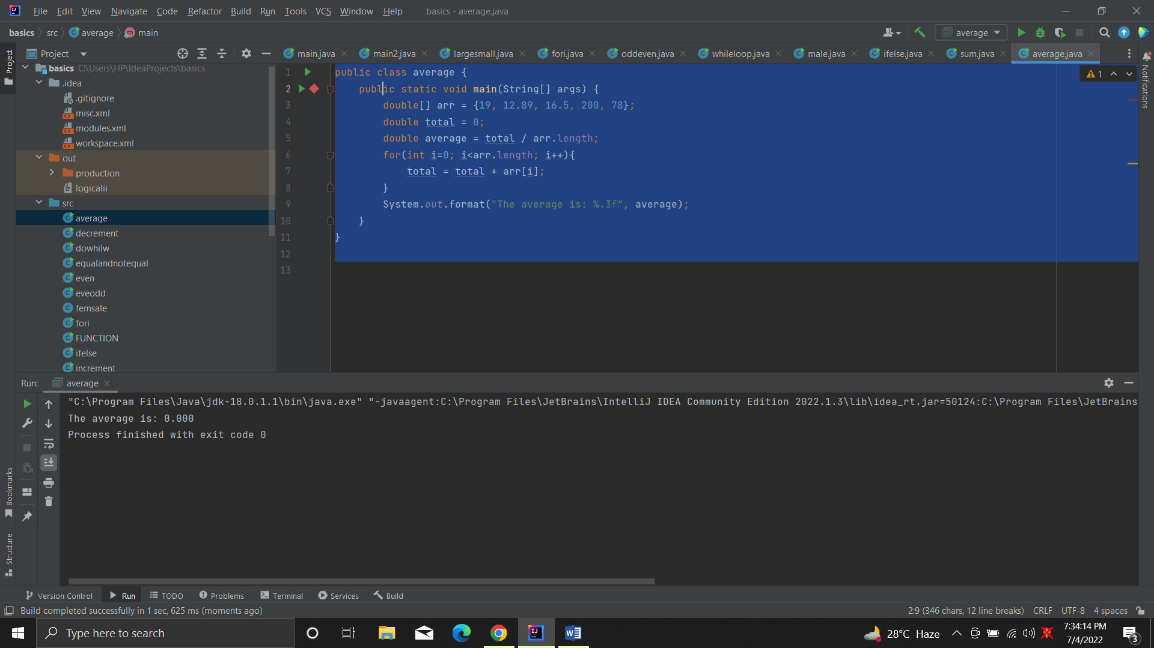

3. public class indexing {  
 public static void main(String[] args) {  
 int array[] = {1, 3, 7};  
 for (int i = 0; array.length > i; i++) {  
 System.*out*.println(i + " Index number Element is " + array[i]);  
 }  
 }  
 }

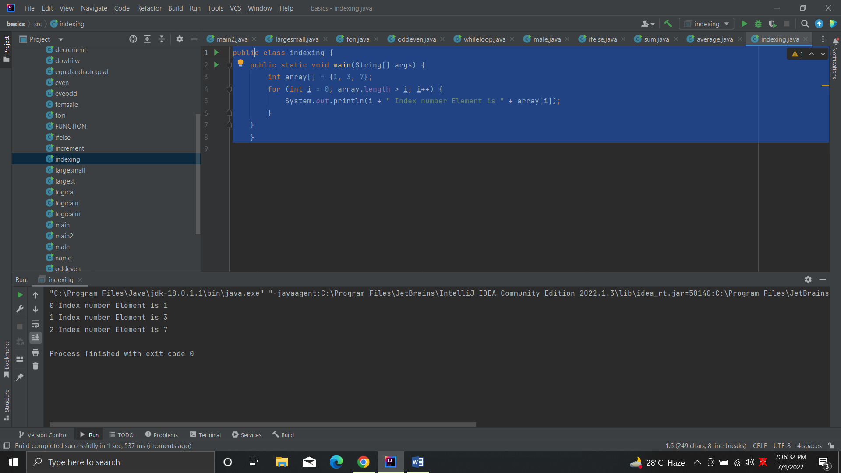

4.